Gel Documentation Form and Worksheet

HLA-B*35 (101.522-24/03, -24u/03u) Lot No: 02X Expiry Date: 2017-January-01

Name:__________________
Sample ID:______________
DNA Conc.(ng/ul):_________

Test Date:_______________
Tested By:_______________

Review Date:_______________
Reviewed By:_______________

Interpretation:___________ Failed lanes: ___________ Comments:_________________

Gel Picture

PHOTO DOCUMENT

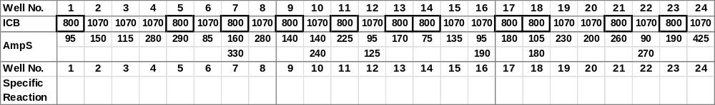

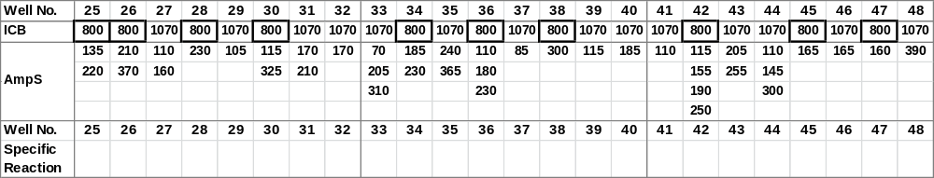
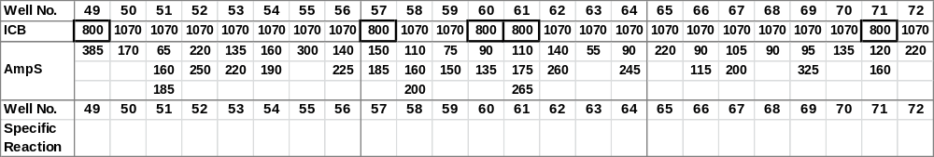
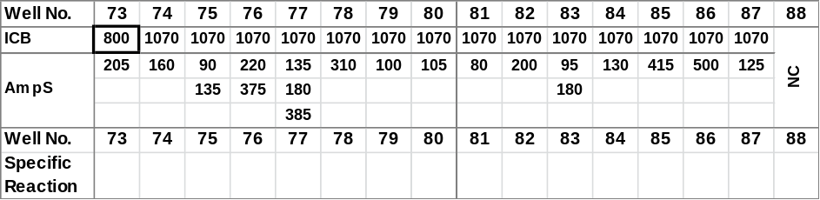

‘ICB’ Internal Control Band,
‘AmpS’ Amplicon Size

Notes:
Product sizes are approximate. For detailed information, see the lot-specific Specificity Table and Interpretation Table.
This table is intended as a guide. For interpretation always use the Interpretation Table and/or Specificity Table.

HLA-specific PCR products shorter than 125 base pairs have a lower intensity and are less sharp than longer PCR products.
Primer mix 7 may faintly amplify the B*44 alleles.
Primer mixes 5, 35, 41, 44, 73 and 76 may have a tendency to giving rise to primer oligomer formation.
Primer mixes 3, 6, 7, 10, 30, 33, 50, 53, 65 and 77 have tendencies of unspecific amplifications.
Primer mixes 8, 17, 20, 27, 47 and 86 may give rise to a lower yield of HLA-specific PCR product than the other HLA-B*35 primer mixes.
¹⁰Primer mix 14 may faintly amplify the B*37 alleles.
¹¹Primer mix 88 contains a negative control, which will amplify more than 95% of HLA amplicons as well as the amplicons generated by control primer pairs. PCR product sizes range from 75 to 200 base pairs. The PCR product generated by the control primer pair is 430 base pairs.

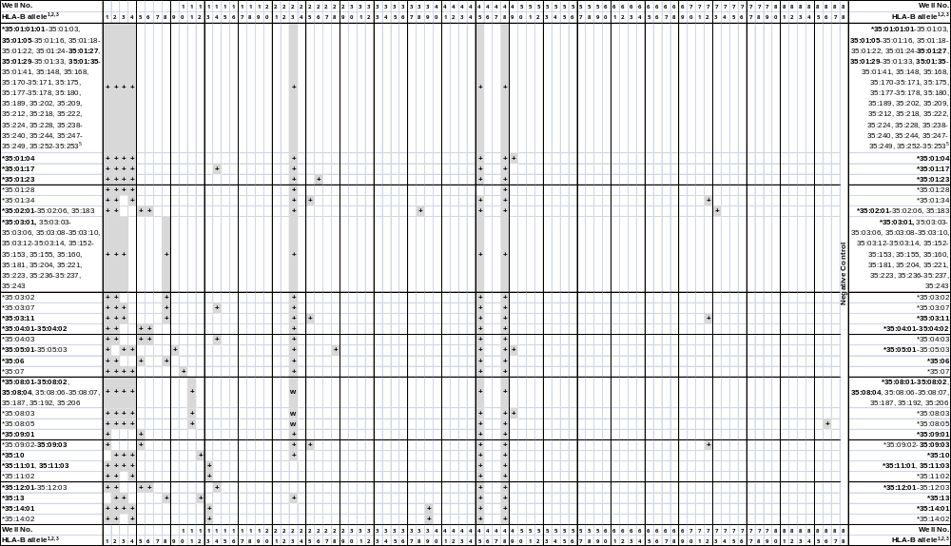
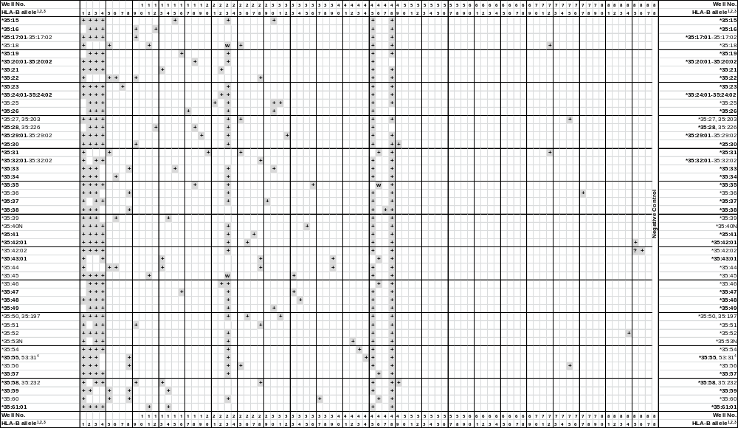
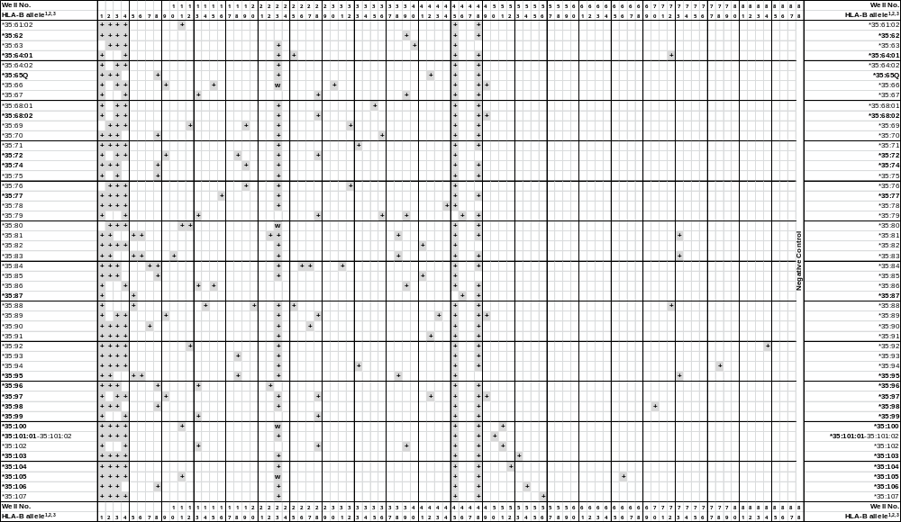
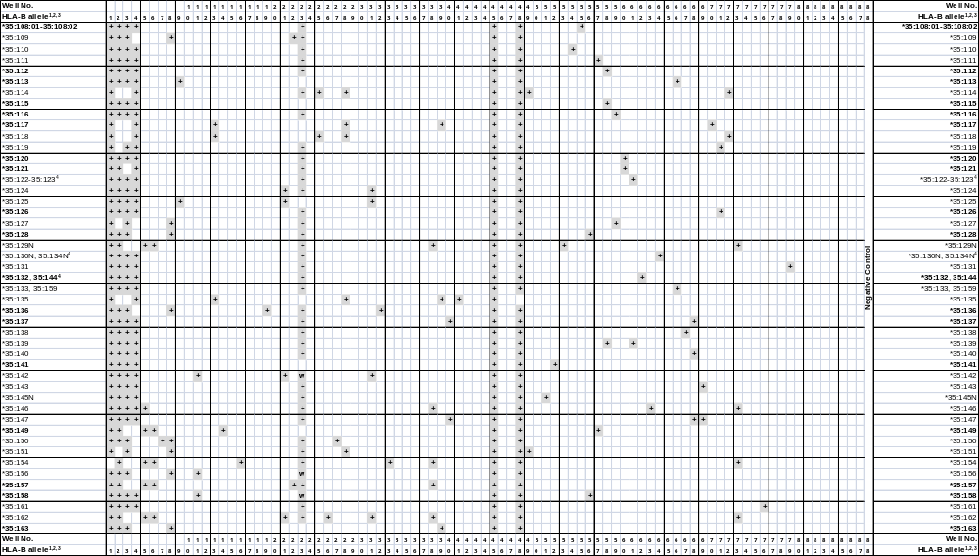
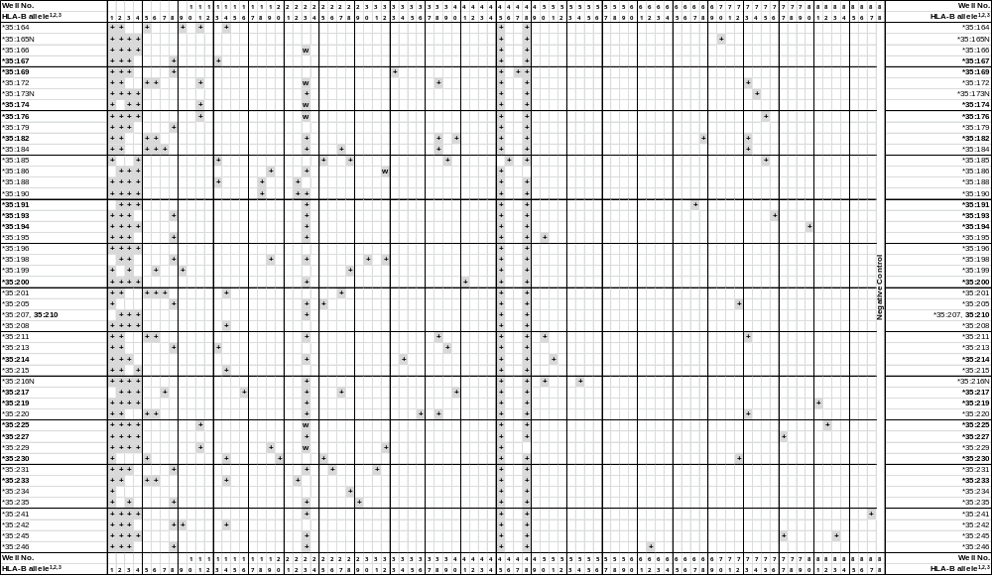
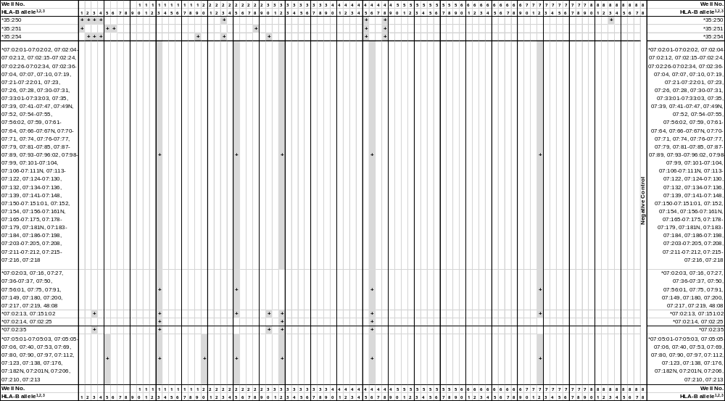
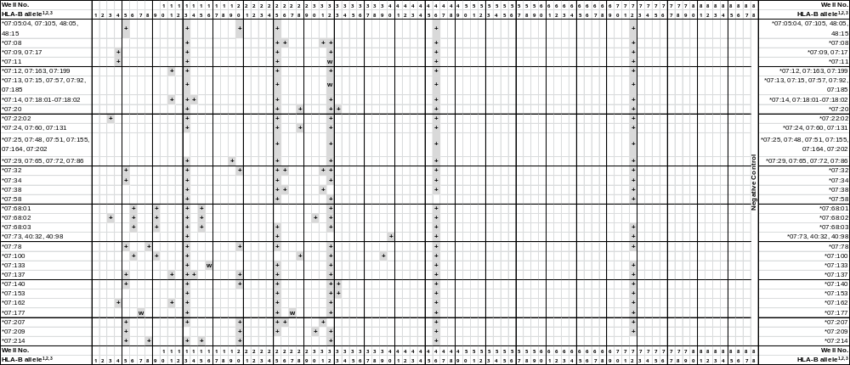

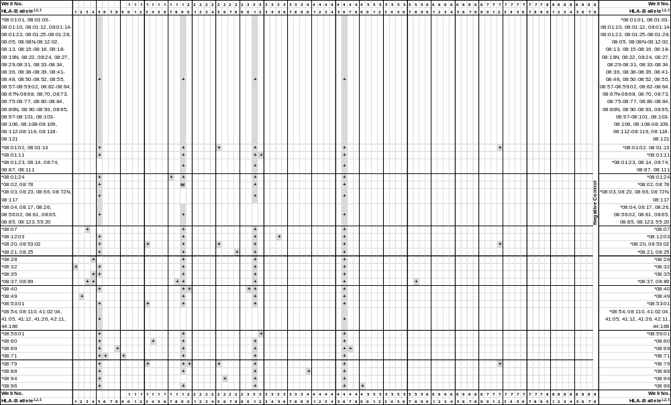
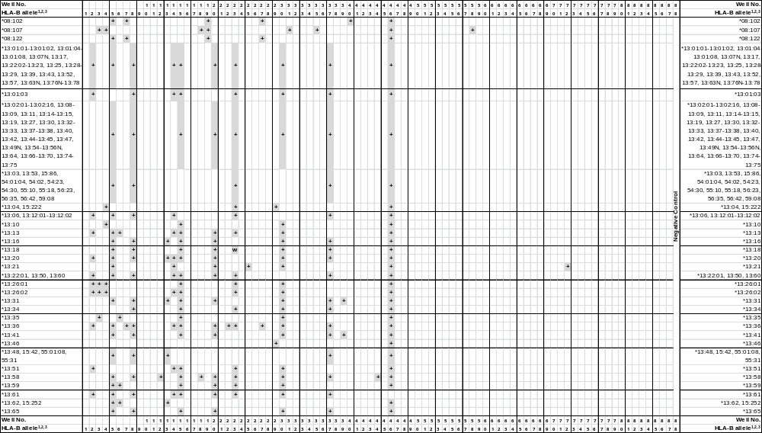
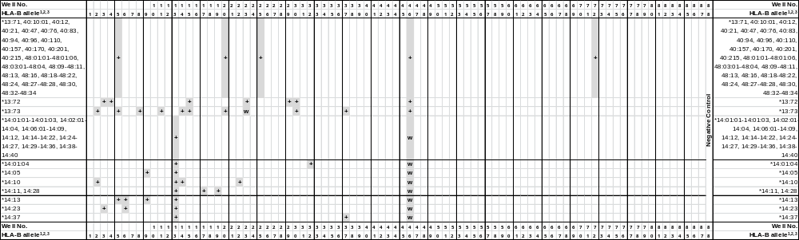
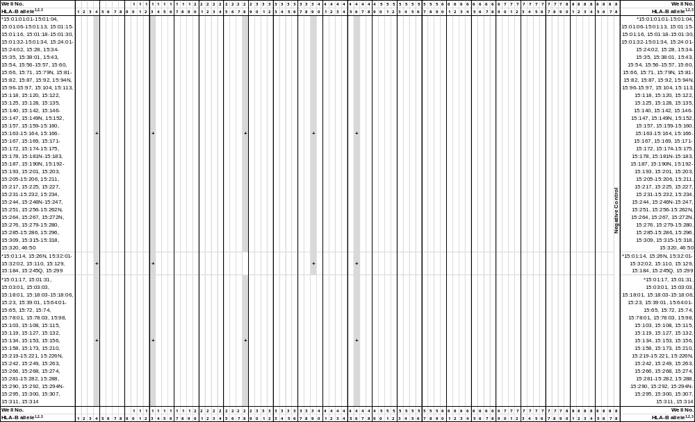
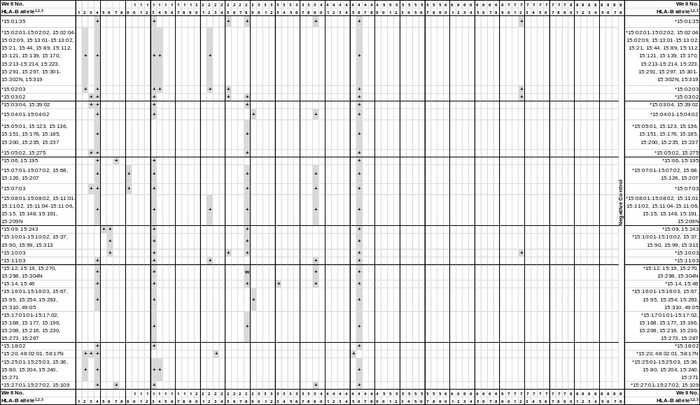
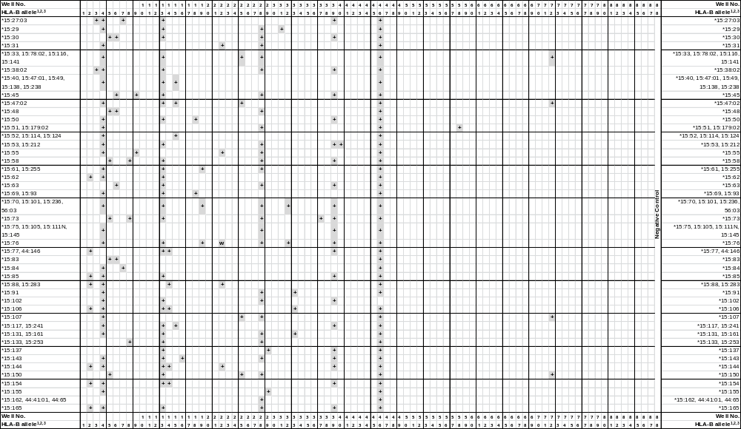
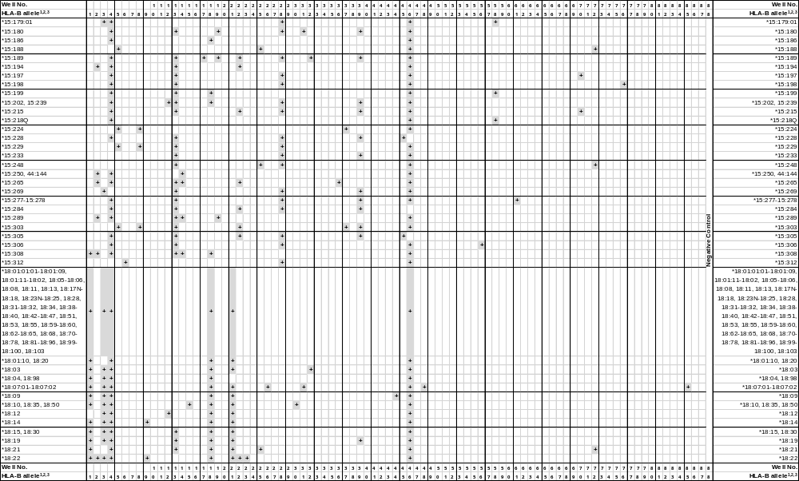
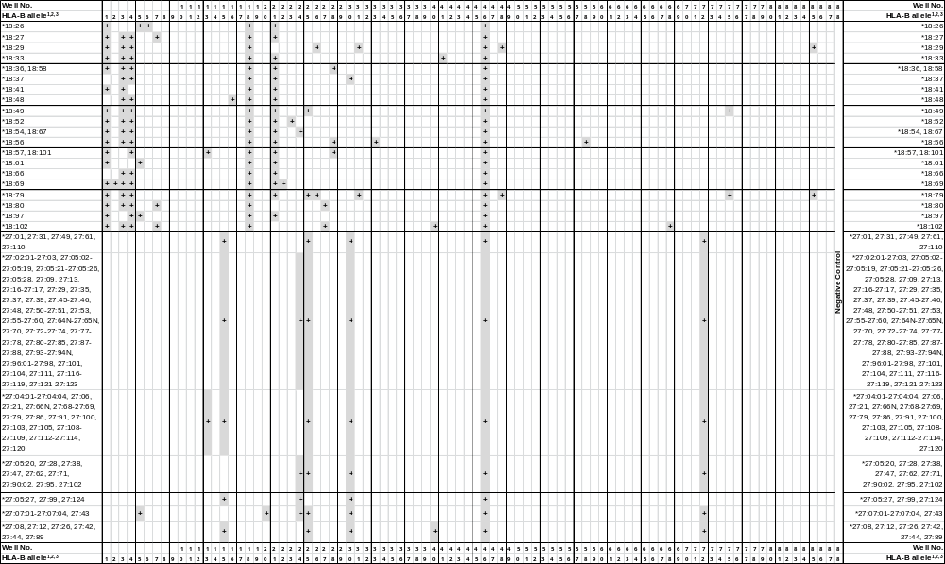
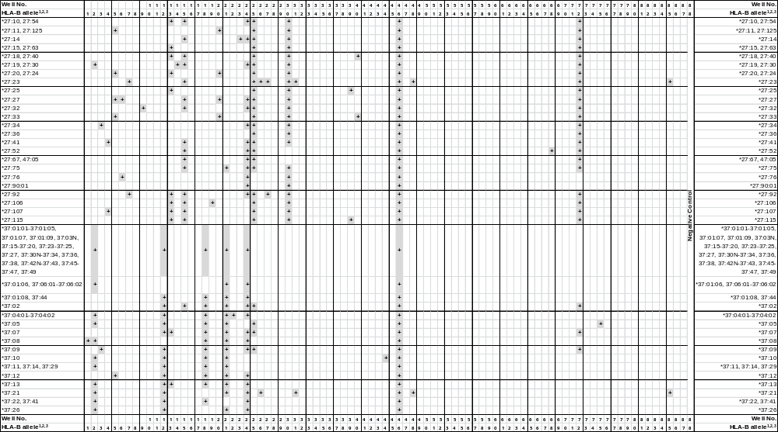
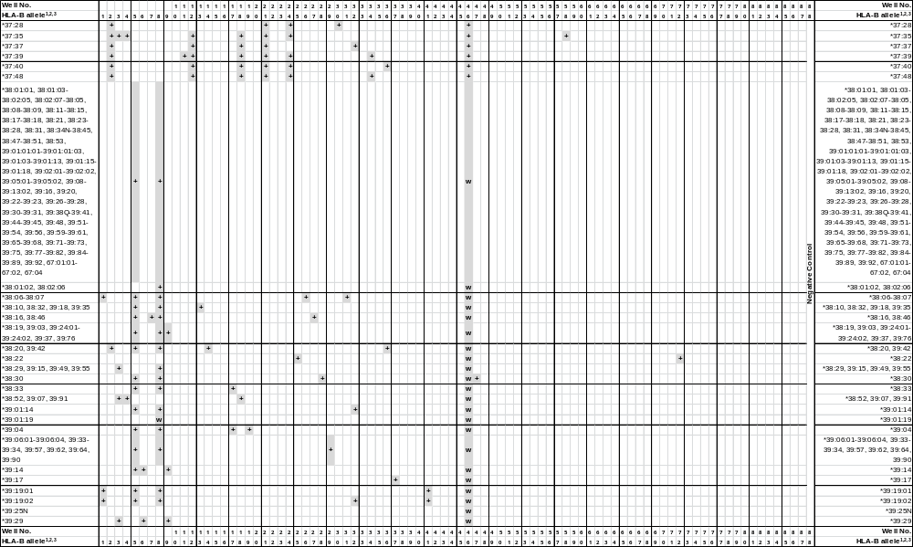
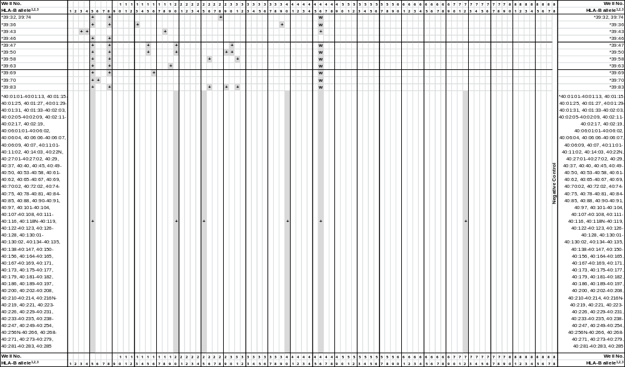
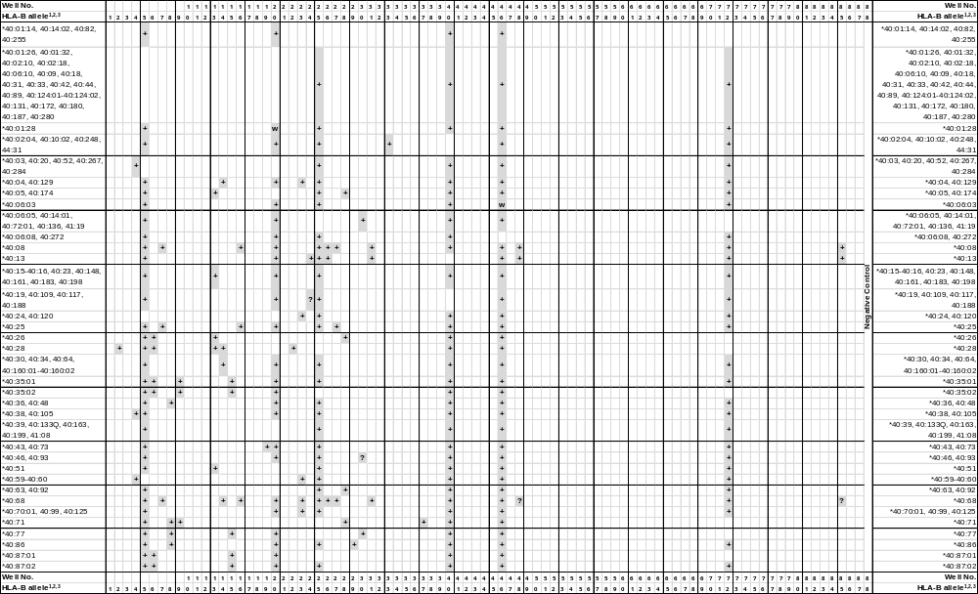
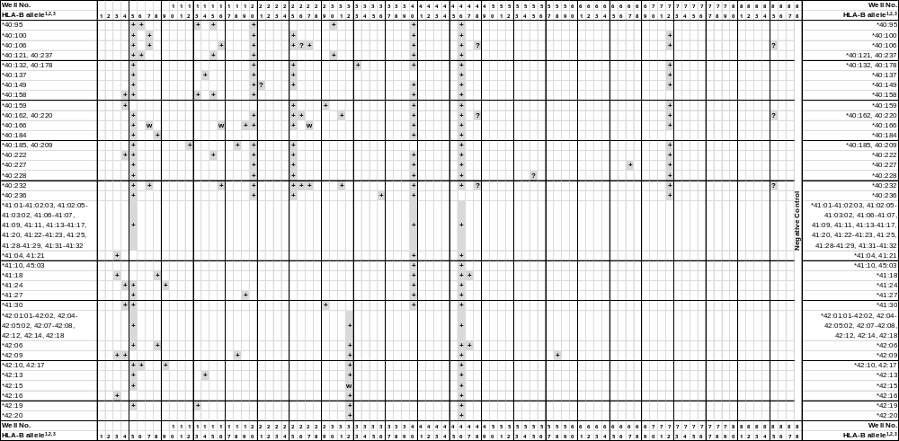
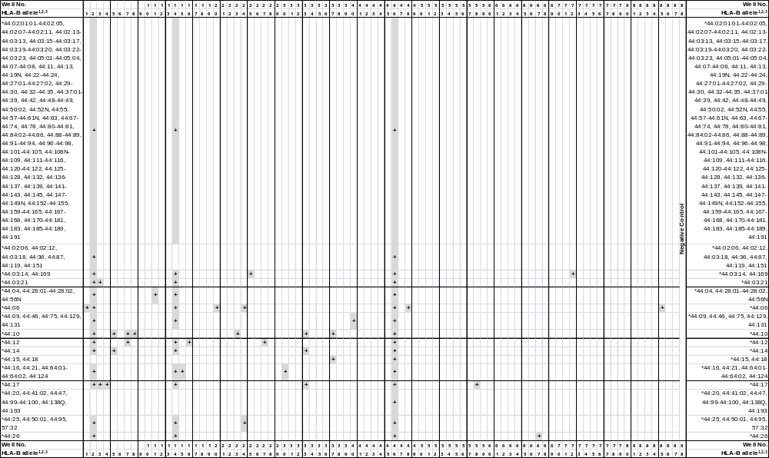
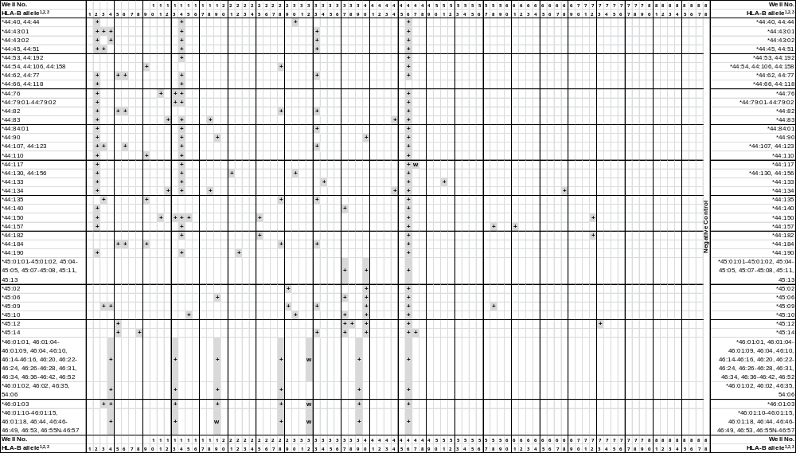
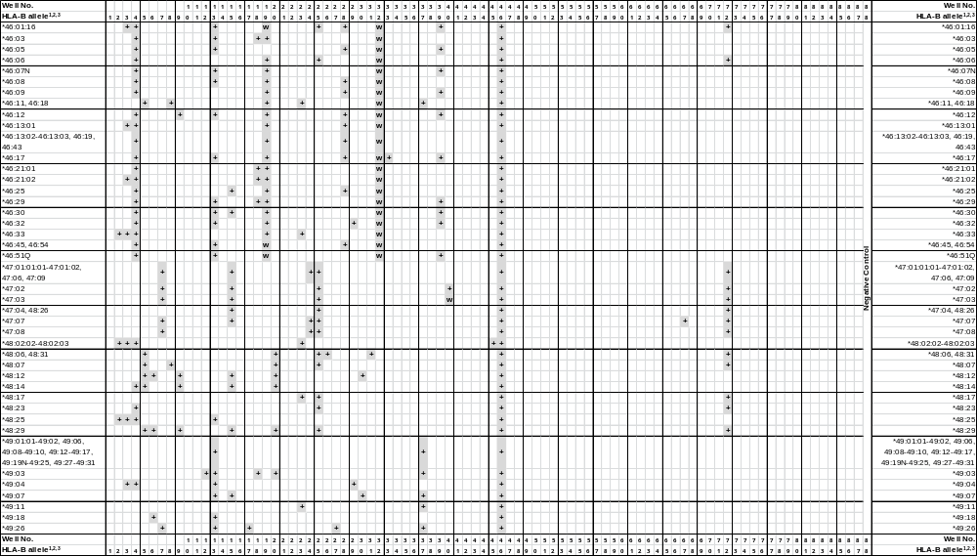
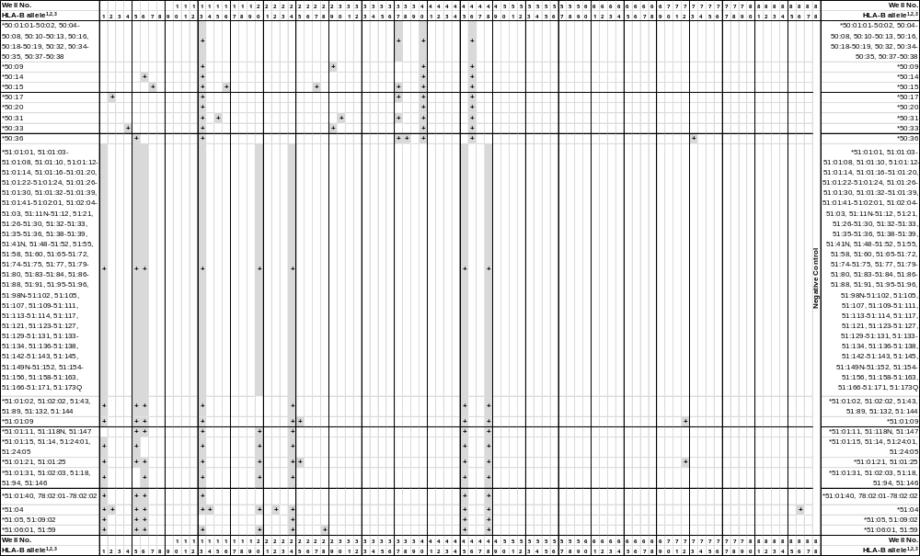
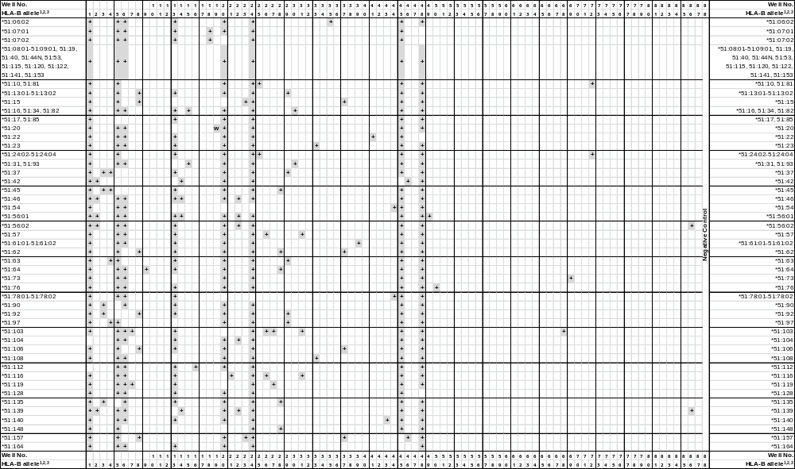
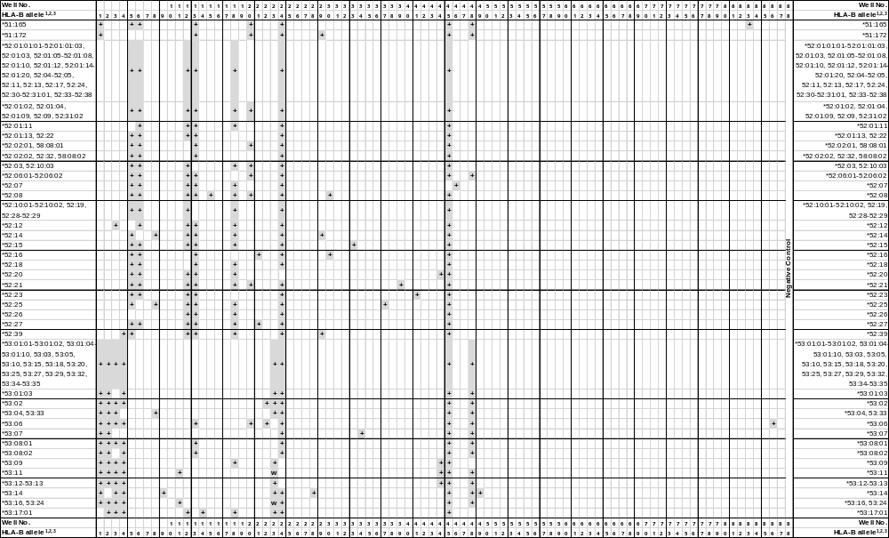
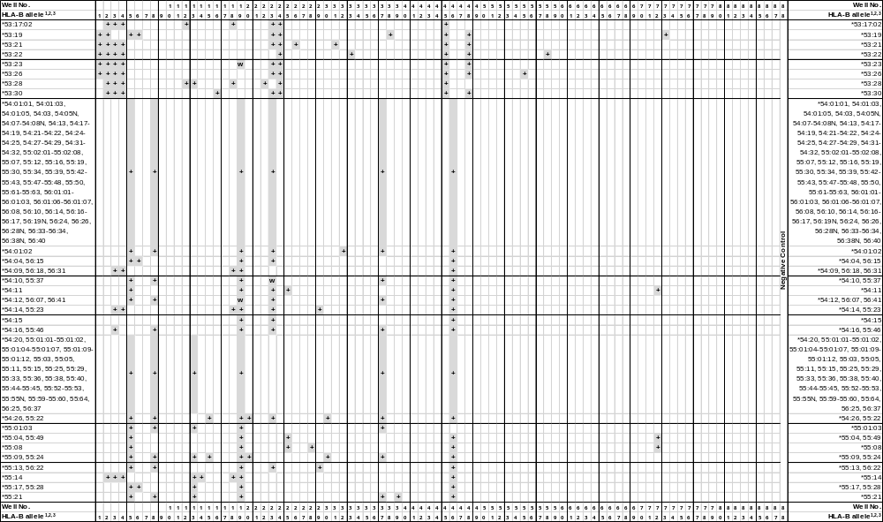
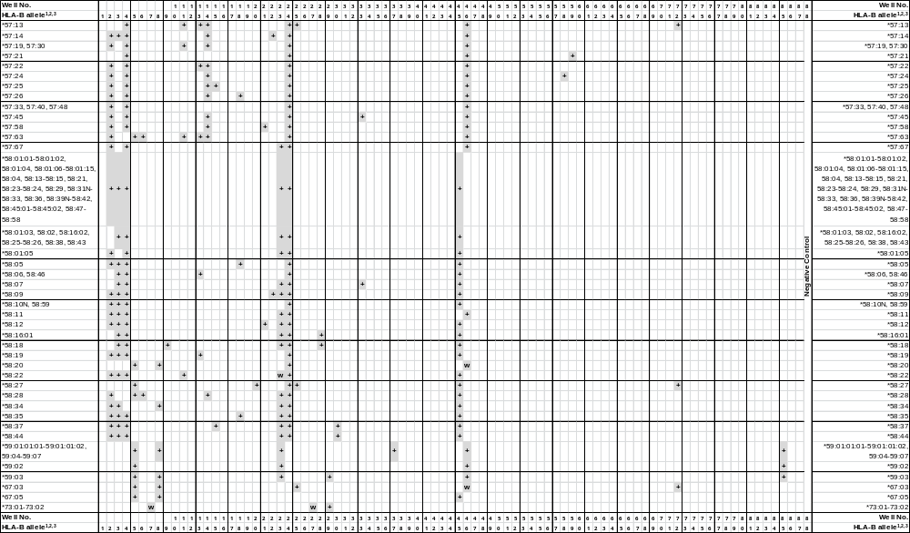
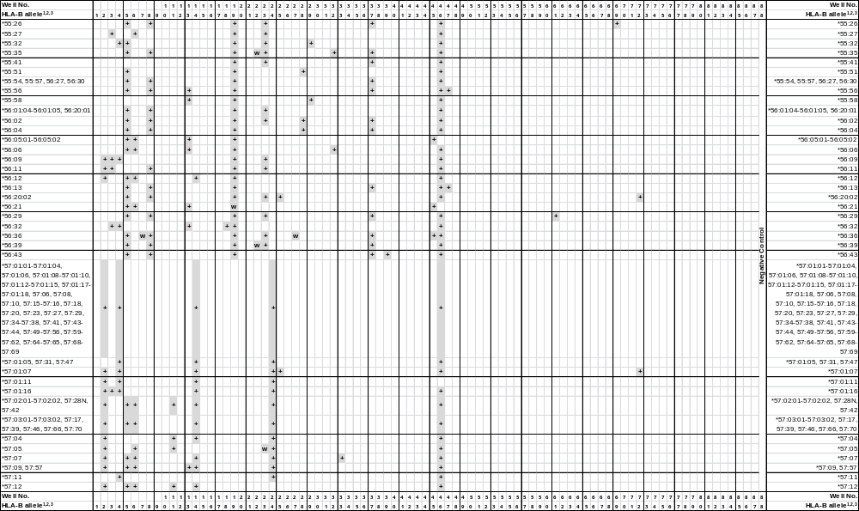
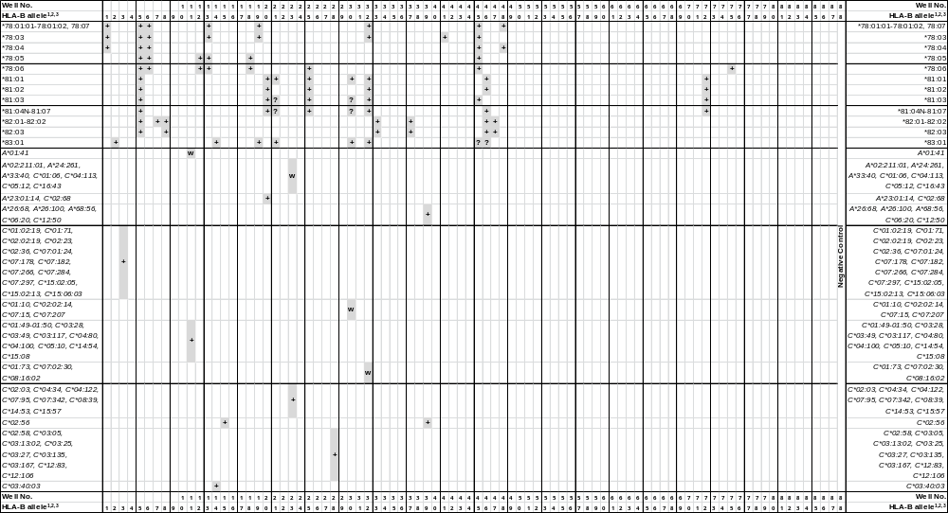
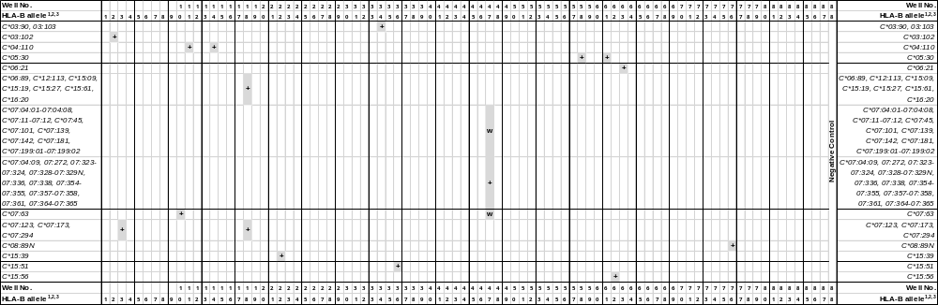
¹HLA-B*35 alleles in bold lettering are listed as confirmed alleles on the IMGT/HLA web page www.ebi.ac.uk/imgt/hla, release 3.16.0, April 2014.
²Alleles that have been deleted from or renamed in the official WHO HLA Nomenclature up to and including the last IMGT/HLA database release can be retrieved from web page http://hla.alleles.org/alleles/deleted.html.
³Primer mix 7: Specific PCR fragment of 160 bp in the B*35:84, 35:90, 35:150, 35:184, 35:201 and 35:217 and the B*07:177^{w}, 08:102, 08:122, 13:36, 18:80, 18:102, 27:23, 27:92, 38:16, 38:46, 40:08, 40:25, 40:68, 40:106, 40:166^{w}, 40:232, 44:12, 49:26, 50:15, 51:103, 51:119, 56:36^{w} and 73:01^{w}-73:02^{w} alleles. Specific PCR fragment of 330 bp in the B*35:23 and the B*15:06, 15:27:01-15:27:03, 15:84, 15:109, 15:195, 18:27, 40:100, 44:10, 47:01:01:01-47:03, 47:06-47:09 and 82:01-82:02 alleles.
Primer mix 10: Specific PCR fragment of 140 bp in the B*35:83 and the C*07:63 alleles. Specific PCR fragment of 240 bp in the B*35:07 allele.
Primer mix 12: Specific PCR fragment of 95 bp in the B*35:10, 35:13, 35:16, 35:28, 35:69, 35:80 and 35:226 and the B*13:58, 15:202, 15:239, 18:12, 37:01:01-37:01:05, 37:01:07-37:05, 37:07, 37:09-37:27, 37:29-37:49, 40:185, 40:209, 44:83, 44:134, 49:03, 52:01:01:01-52:01:20, 52:03-52:15, 52:17, 52:19-52:31:02, 52:33-52:39, 53:17:01-53:17:02, 53:28 and 78:05-78:06 alleles. Specific PCR fragment of 125 bp in the B*35:92 allele.
Primer mix 16: Specific PCR fragment of 95 bp in the B*35:19, 35:47, 35:154 and 35:217 and the B*07:133^{w}, 15:143, 18:48, 39:69, 40:08, 40:25, 40:68, 40:106, 40:166^{w}, 40:232, 44:12, 50:15, 51:112 and 53:30 alleles. Specific PCR fragment of 190 bp in the B*35:77 allele.
Primer mix 18: Specific PCR fragment of 105 bp in the B*35:20:01-35:20:02, 35:28, 35:72, 35:95 and 35:226 and the B*13:58, 15:202, 15:239, 15:308, 18:01:14, 18:01:18, 18:10, 18:20-18:21 18:26, 18:35-18:36 18:41, 18:50, 18:56-18:58 18:61, 18:86, 18:97, 18:101, 37:01:01-37:01:05, 37:01:07-37:05, 37:07-37:20, 37:22-37:25, 37:27, 37:29-37:34, 37:36-37:49, 40:185, 40:209, 44:83, 44:134, 49:03, 51:07:01-51:07:02, 52:01:01:01-52:01:12, 52:01:14-52:01:20, 52:03-52:05, 52:07-52:15, 52:17-52:21, 52:24-52:31:02, 52:33-52:39, 53:09, 53:17:01-53:17:02, 53:28 and 78:05-78:06 alleles. Specific PCR fragment of 180 bp in the B*35:35, 35:93, 35:188 and 35:190 and the B*08:37, 08:89, 08:107, 15:50, 15:69, 15:93, 15:186, 15:199, 18:07:01-18:07:02, 18:29, 18:33, 18:37, 18:48, 18:66, 18:79, 38:52, 39:07, 39:43, 39:91, 42:09, 46:03, 46:21:01-46:21:02, 46:29, 54:09, 54:14, 55:14, 55:23, 56:18, 56:31-56:32, 57:26, 58:05, 58:35 and in the C*06:89, C*07:123, C*07:173, C*07:294, C*12:113, C*15:09, C*15:19, C*15:27, C*15:61 and C*16:20 alleles. Specific PCR fragment of 105 and 180 bp in the B*18:01:01:01-18:01:13, 18:01:15-18:01:17, 18:01:19-18:06, 18:08-18:09, 18:11-18:15, 18:17N-18:19, 18:22-18:25, 18:27-18:28, 18:30-18:32, 18:34, 18:38-18:40, 18:42-18:47, 18:49, 18:51-18:55, 18:59-18:60, 18:62-18:65, 18:67-18:78, 18:80-18:85, 18:87-18:96, 18:98-18:100, 18:102-18:103 and 37:35 alleles. Both specific fragments may not always be obtained.
Primer mix 22: Specific PCR fragment of 90 bp in the B*35:46 and the B*13:36, 15:02:01-15:02:09, 15:08:01-15:08:02, 15:11:01-15:11:06, 15:13:01-15:13:02, 15:15, 15:21, 15:31, 15:44, 15:55, 15:76^{w}, 15:88-15:89, 15:112, 15:121, 15:139, 15:144, 15:148, 15:170, 15:189, 15:191, 15:194, 15:209N, 15:213-15:215, 15:223, 15:265, 15:283-15:284, 15:291, 15:297, 15:301-15:303, 15:305, 15:319, 51:104, 55:35^{w} and 56:39^{w} alleles. Specific PCR fragment of 270 bp in the B*35:21, 35:24:01-35:24:02, 35:81, 35:96, 35:109, 35:157, 35:188, 35:190 and 35:233 and the B*14:10, 18:22, 18:69, 37:04:01-37:04:02, 40:28, 44:190, 51:04, 51:46, 51:56:01-51:56:02, 51:139, 53:02, 53:06, 53:28, 57:14 and 58:09 and in the C*15:39 alleles.
Primer mix 25: Specific PCR fragment of 135 bp in the B*35:27, 35:56, 35:185 and 35:203 and the B*18:49, 18:79, 37:05 and 78:06 alleles. Specific PCR fragment of 220 bp in the B*35:01:34, 35:03:11, 35:09:02-35:09:03, 35:18, 35:31, 35:64:01, 35:88, 35:114, 35:118, 35:205 and 35:230 and the B*07:02:01-07:02:13, 07:02:15-07:02:24, 07:02:26-07:02:34, 07:02:36-07:67N, 07:68:03-07:99, 07:101-07:213, 07:215-07:219, 08:01:02, 08:01:13, 08:20, 08:53:02, 08:79, 13:21, 13:71, 15:01:35, 15:02:03, 15:03:02, 15:10:03, 15:33, 15:47:02, 15:78:02, 15:107, 15:116, 15:141, 15:150, 15:188, 15:248, 18:21, 27:01-27:05:26, 27:05:28-27:21, 27:23-27:75, 27:77-27:89, 27:90:02-27:98, 27:100-27:123, 27:125, 37:02, 37:07, 37:09, 38:22, 40:01:01-40:01:13, 40:01:15-40:06:04, 40:06:06-40:13, 40:14:03-40:16, 40:18-40:25, 40:27:01-40:27:02, 40:29-40:35:01, 40:36-40:40, 40:42-40:70:02, 40:72:02-40:76, 40:78-40:81, 40:83-40:86, 40:87:02-40:94, 40:96-40:120, 40:122-40:135, 40:137-40:157, 40:159-40:183, 40:185-40:236, 40:238-40:254, 40:256N-40:285, 41:08, 44:03:14, 44:31, 44:150, 44:169, 44:182, 46:01:16, 46:06, 47:01:01:01-47:09, 48:01:01-48:01:06, 48:03:01-48:11, 48:13, 48:15-48:24, 48:26-48:34, 51:01:09, 51:01:21, 51:01:25, 51:10, 51:24:02-51:24:04, 51:81, 54:11, 55:04, 55:08, 55:49, 56:20:02, 57:01:07, 57:13, 58:27, 67:03 and 81:01-81:07 alleles.
Primer mix 26: Specific PCR fragment of 210 bp in the B*35:50, 35:84, 35:162, 35:197 and 35:231 and the B*07:08, 07:32, 07:38, 07:207, 08:94, 38:06-38:07, 39:58, 39:83, 48:06, 48:31, 51:57, 51:103, 51:116 and 53:21 alleles. Specific PCR fragment of 370 bp in the B*35:01:23, 35:42:01 and B*40:106? alleles. Specific PCR fragment of 210 and 370 bp in the B*18:07:01-18:07:02, 18:29, 18:79, 27:23, 37:21, 40:08, 40:13, 40:68, 40:162, 40:220 and 40:232 alleles.
Primer mix 27: Specfic PCR fragment of 110 bp in the B*35:41 allele. Specific PCR fragment of 160 bp in the B*35:84, 35:90, 35:150, 35:184, 35:201 and 35:217 and the B*07:177^{w}, 08:102, 08:122, 13:36, 18:80, 18:102, 27:23, 27:92, 38:16, 38:46, 40:08, 40:25, 40:68, 40:106, 40:166^{w}, 40:232, 44:12, 49:26, 50:15, 51:103, 51:119, 56:36^{w}, 73:01^{w}-73:02^{w} alleles.
Primer mix 30: Specific PCR fragment of 115 bp in the B*35:15, 35:33 and 35:66 and the B*07:02:13, 07:02:35, 07:68:02, 07:151:02, 07:209, 08:40, 13:01:01-13:02:16, 13:07N-13:11, 13:13-13:21, 13:22:02-13:23, 13:25-13:45, 13:47, 13:49N, 13:51-13:52, 13:54-13:59, 13:61, 13:63N-13:70, 13:72-13:78, 18:10, 18:35, 18:50, 39:47, 39:50, 40:06:05, 40:14:01, 40:72:01, 40:77, 40:95, 40:121, 40:136, 40:237, 41:19, 44:16, 44:21, 44:64:01-44:64:02, 44:124, 45:10, 48:12, 49:07, 50:31, 51:16, 51:31, 51:34, 51:82, 51:93, 52:08, 54:26, 55:09, 55:22, 55:24 and 58:37 and in the C*01:10^{w}, C*02:02:14^{w}, C*07:15^{w}, 07:207^{w} alleles. Specific PCR fragment of 325 bp in the B*35:25-35:26, 35:49, 35:198, 35:254, 18:37, 27:01-27:21, 27:23-27:51, 27:53-27:66N, 27:68-27:89, 27:90:02-27:125, 37:28, 40:46?, 40:93?, 44:40, 44:44, 44:130, 44:156, 52:16, 58:44, 81:01, 81:03?-81:07?, 83:01alleles. Specific PCR fragment of 115 and 325 bp in the B*27:90:01 allele.
Primer mix 31: Specific PCR fragment of 170 bp in the B*35:25, 35:124-35:125 and 35:142 and the B*08:01:01-08:03, 08:05, 08:07-08:16, 08:18-08:25, 08:27-08:53:02, 08:55, 08:57-08:60, 08:62-08:64, 08:66-08:84, 08:86N-08:93, 08:95-08:101, 08:103-08:109, 08:111-08:121, 15:29 and 15:180 alleles. Specific PCR fragment of 210 bp in the B*35:50, 35:84, 35:197 and 35:231 and the B*18:29, 27:23, 40:08, 40:13, 40:68, 40:162, 40:220, 40:232, 51:57, 51:103 and 53:21 alleles. Specific PCR fragment of 170 and 210 bp in the B*35:162 and in the B*07:08, 07:32, 07:38, 07:207, 08:94, 18:07:01-18:07:02, 18:79, 37:21, 38:06-38:07, 39:58, 39:83, 48:06, 48:31 and 51:116 alleles.
Primer mix 33: Specific PCR fragment of 70 bp in the B*35:47 and 35:154 and the B*15:46, 15:106, 40:02:04, 40:10:02, 44:84:01 and 57:45 alleles. Specific PCR fragment of 205 bp in the B*35:45, 35:71 and 35:169 and the B*07:20, 07:140, 07:153, 15:14, 15:91, 15:131, 15:161, 18:56, 40:132, 40:178, 44:10, 44:14, 44:17, 44:31, 44:43:01-44:43:02, 44:45, 44:51, 44:62, 44:77, 44:82, 44:107, 44:123, 44:135, 44:184, 45:09, 45:14, 46:17, 51:23, 51:108, 52:15, 53:22, 57:07, 58:07 and 82:01-82:03 alleles. Specific PCR fragment of 310 bp in the B*35:94 allele.
Primer mix 34: Specific PCR fragment of 185 bp in the B*35:214 and the B*44:133 alleles. Specific PCR fragment of 230 bp in the B*35:48 and the B*37:39, 37:48 and 53:07 and in the C*03:90 and 03:103 alleles.
Primer mix 35: Specific PCR fragment of 240 bp in the B*35:40N allele. Specific PCR fragment of 365 bp in the B*35:68:01 and the B*08:12:03, 08:107 and 51:06:02 alleles.
Primer mix 36: Specific PCR fragment of 110 bp in the B*35:79 allele. Specific PCR fragment of 180 bp in the B*35:70 and 35:220 and the B*40:236 alleles. Specific PCR fragment of 230 bp in the B*35:35 and the B*15:265, 37:40, 38:20 and 39:42 and in the C*15:51alleles.
Primer mix 42: Specific PCR fragment of 115 bp in the B*35:97 allele. Specific PCR fragment of 155 bp in the B*35:53N allele. Specific PCR fragment of 190 bp in the B*35:91 allele. Specific PCR fragment of 250 bp in the B*35:65Q allele.
Primer mix 43: Specific PCR fragment of 205 bp in the B*35:54 and the B*51:140 alleles. Specific PCR fragment of 255 bp in the B*35:89 allele.
Primer mix 44: Specific PCR fragment of 110 bp in the B*35:78 allele. Specific PCR fragment of 145 bp in the B*13:58, 18:09, 37:10, 44:83, 44:134, 51:54, 51:78:01-51:78:02, 52:20, 53:09, 53:11-53:13 and 53:31 alleles. Specific PCR fragment of 300 bp in the B*35:55 allele.
Primer mix 51: Specific PCR fragment of 65 bp in the B*35:145N allele. Specific PCR fragment of 160 bp in the B*35:100 and 35:102 alleles. Specific PCR fragment of 185 bp in the B*35:214 and the 44:133 alleles.
Primer mix 52: Specific PCR fragment of 220 bp in the B*35:141 allele. Specific PCR fragment of 250 bp in the B*35:104 allele.
Primer mix 53: Specific PCR fragment of 135 bp in the B*35:103 allele. Specific PCR fragment of 220 bp in the B*35:129N allele.
Primer mix 54: Specific PCR fragment of 160 bp in the B*35:106 and 35:216N alleles. Specific PCR fragment of 190 bp in the B*35:110 allele.
Primer mix 56: Specific PCR fragment of 140 bp in the B*35:128 allele. Specific PCR fragment of 225 bp in the B*35:107 and 35:158 and the B*15:306 alleles.
Primer mix 57: Specific PCR fragment of 150 bp in the B*35:149 allele. Specific PCR fragment of 185 bp in the B*35:111 allele.
Primer mix 58: Specific PCR fragment of 110 bp in the B*35:139 and the B*44:157 and in the C*05:30 alleles. Specific PCR fragment of 160 bp in the B*35:115 and the B*08:37, 08:89, 08:107, 15:51, 15:179:01-15:179:02, 15:199, 15:218Q, 18:56, 37:35, 42:09, 44:17, 45:09, 53:22 and 57:24 alleles. Specific PCR fragment of 200 bp in the B*35:112 allele.
Primer mix 59: Specific PCR fragment of 75 bp in the B*35:116 allele. Specific PCR fragment of 150 bp in the B*35:127 and the B*57:21 alleles.
Primer mix 60: Specific PCR fragment of 90 bp in the B*35:121 allele. Specific PCR fragment of 135 bp in the B*35:120 allele.
Primer mix 61: Specific PCR fragment of 110 bp in the B*35:139 and the B*44:157 and in the C*05:30 alleles. Specific PCR fragment of 175 bp in the B*35:122 and the B*15:277-15:278 and 56:29 alleles. Specific PCR fragment of 265 bp in the B*35:123 allele.
Primer mix 62: Specific PCR fragment of 140 bp in the B*35:144 allele. Specific PCR fragment of 260 bp in the B*35:132 and 35:246 and the C*15:56 alleles.
Primer mix 64: Specific PCR fragment of 90 bp in the B*35:130N allele. Specific PCR fragment of 245 bp in the B*35:134N allele.
Primer mix 66: Specific PCR fragment of 90 bp in the B*35:133 allele. Specific PCR fragment of 115 bp in the B*35:105, 35:113 and 35:159 alleles.
Primer mix 67: Specific PCR fragment of 105 bp in the B*35:138 and the B*44:26 and 47:07 alleles. Specific PCR fragment of 200 bp in the B*35:191 and the B*40:227 alleles.
Primer mix 69: Specific PCR fragment of 95 bp in the B*35:143 and in the B*51:73 and 55:26 alleles. Specific PCR fragment of 325 bp in the B*35:147 allele.
Primer mix 71: Specific PCR fragment of 120 bp in the B*35:126 allele. Specific PCR fragment of 160 bp in the B*35:119 allele.
Primer mix 75: Specific PCR fragment of 90 bp in the B*35:176 allele. Specific PCR fragment of 135 bp in the B*35:27, 35:56, 35:185 and 35:203 and the B*18:49, 18:79, 37:05 and 78:06 alleles.
Primer mix 76: Specific PCR fragment of 220 bp in the B*35:193 and in the C*08:89N allele. Specific PCR fragment of 375 bp in the B*35:161 and the B*15:198 alleles.
Primer mix 77: Specific PCR fragment of 135 bp in the B*35:227 allele. Specific PCR fragment of 180 bp in the B*35:245 allele. Specific PCR fragment of 385 bp in the B*35:36 allele.
Primer mix 83: Specific PCR fragment of 95 bp in the B*35:250 and the B*51:165 alleles. Specific PCR fragment of 180 bp in the B*35:245 allele.
‘w’, might be weakly amplified.
‘?’, nucleotide sequence of the primer matching region not known.

⁴The following HLA-B*35 alleles can be distinguished by the different sizes of the HLA-specific PCR product:

Alleles | Primer mix
B*35:55, 53:31 | 44
B*35:122, 35:123 | 61
B*35:130N, 35:134N | 64
B*35:132, 35:144 | 62

The HLA-B*35 subtyping kit cannot distinguish the following silent mutations: the B*35:01:01:01-35:01:03, 35:01:05-35:01:16, 35:01:18-35:01:22, 35:01:24-35:01:27, 35:01:29-35:01:33 and 35:01:35-35:01:41, the B*35:02:01-35:02:06, the B*35:03:01, 35:03:03-35:03:06, 35:03:08-35:03:10 and 35:03:12-35:03:14, the B*35:04:01-35:04:02, the B*35:05:01-35:05:03, the B*35:08:01-35:08:02, 35:08:04 and 35:08:06-35:08:07, the B*35:09:02-35:09:03, the B*35:11:01 and B*35:11:03, the B*35:12:01-35:12:03, the 35:17:01-35:17:02, the B*35:20:01-35:20:02, the B*35:24:01-35:24:02, the B*35:29:01-35:29:02, the B*35:32:01-35:32:02, the B*35:101:01-35:101:02 or the B*35:108:01-35:108:02 alleles.

⁵This lot of the HLA-B*15 subtyping kit cannot distinguish the B*35:01:01:01-35:01:03, 35:01:05-35:01:16, 35:01:18-35:01:22, 35:01:24-35:01:27, 35:01:29-35:01:33 and 35:01:35-35:01:41 alleles and the B*35:148 allele.

Change in revision R01 compared to R00:
- Primer mix 65 does not amplify the B*35:148 allele. This has been corrected in the Specificity and Interpretation Tables. Thus, this lot of the HLA-B*15 subtyping kit cannot distinguish the B*35:01:01:01-35:01:03, 35:01:05-35:01:16, 35:01:18-35:01:22, 35:01:24-35:01:27, 35:01:29-35:01:33 and 35:01:35-35:01:41 alleles and the B*35:148 allele.
Change in revision R02 compared to R01:
- Primer mix 32 amplifes the B*07:109 and *18:03 alleles. This has been corrected in the Specificity and Interpretation Tables.
Changes in revision R03 compared to R02:
- Primer mix 86 may give rise to a lower yield of HLA-specific PCR product than the other HLA-B*35 resolution primer mixes. A foot note has been added in the Specificity Table.
Change in revision R04 compared to R03:
- Primer mix 24 does amplify the B*52:28 allele. Primer mix 37 does not amplify the C*03:102 allele. This has been corrected in the Specificity and Interpretation Tables.
Change in revision R05 compared to R04:
- Primer mix 37 amplifies the B*54:16 and B*55:46 alleles. This has been corrected in the Specificity and Interpretation Tables.

